Project Proposal

**Group members:**

* Xuan Minh Le (2020704)
* Aldo Estefani Medrano La Rotta (2032115)
* Eraste Yacov Jesumen Boko (1932826)

**LOGO**



**Table of contents:**

**Project Name: Yummy Joy** **3**

Goals: 3

How the App works: 3

**Users’ features** **4**

**Application Requirements** **5**

Client's requirement 5

**FUNCTIONAL REQUIREMENTS** **5**

**NON-FUNCTIONAL REQUIREMENTS** **5**

Restaurants/Stores requirements 7

**FUNCTIONAL REQUIREMENTS** **7**

**NON-FUNCTIONAL REQUIREMENTS** **7**

**Backlog/poker planning** **8**

**Prototype** **11**

**Product Implementation** **12**

Backend 12

Frontend 15

# Project Name: Yummy Joy

Date: Sept 7, 2022

Mission: We are creating a mobile application that will help people buy food at a cheaper price and also fight against food waste.

## Goals:

* Fight against food waste.
* To reduce the cost of preparing daily meals with special offers.
* To offer a special deal to people who are not able to afford the standard price of a meal.

things

## How the App works:

When a restaurant has food that hasn't sold or is about to expire, they can register the item they want to sell at a steep discount from the original price, along with a description of the item, on the application. Customers looking to place an order can use the app to find businesses in their area with perishable goods that have yet to be purchased. They'll have the option of setting the radius (say, 5 km) within which they look for these directives. When a customer selects a restaurant or shop using the app, they may view the establishment's current menu and prices with a single click. Afterward, the customer can make a reservation for the meal, which the restaurant or shop will hold for a certain amount of time (e.g., 30, 20, or 10 minutes available for reservation). The user will receive a reminder from the app when it is time to pick up his order. If the buyer doesn't show up, you get to keep the thing.

The restaurant or shop must update the number of remaining meals or items that can be reserved, as well as the number of meals or products that are now available, the time it will take to get the meal, and how long the restaurant or shop will hold the reservation.

**The app would connect users with local grocery stores and supermarkets that have surplus food that is close to its expiration date. These stores could then offer this food at a discounted price to users of the app.**

**Users can browse through the available deals and discounts on food items and make a purchase through the app. They would then be able to pick up their purchases at the store or have them delivered to their home.**

**The app would also include a feature that allows users to track the expiration dates of their purchases and receive reminders to consume or use the food before it goes bad. This would help to reduce the amount of food waste in households.**

**The app could also include a feature that allows users to share surplus food with others in their community, such as neighbors or local food banks. This would help to further reduce food waste and provide food to those in need.**

**The app could also include an rewards program for users that buy food with short expiration dates, encouraging them to continue to make more sustainable choices.**

**The application can also be linked to other apps that can make suggestions of recipes to cook with the ingredients they just bought.**

**The application can also have a rating system where users can rate the quality and quantity of food they received, and a feedback system that allows users to report any issues with the food they received.**

# Users’ features

The application is based on two main users, which are:

Customer:

* The customer registers on the app.
* The customer creates a user and password to access the app.
* After successful registration, the user is allowed to search for the meals or products offered by either the restaurant or grocery store according to the search criteria.
* The user selects the place and the item that wants to reserve.
* The customer will receive an electronic receipt showing his reservation information.
* The customer will receive a notification of the remaining time to pick up the item.
* The customer will receive a notification that the reservation will be lost if they do not show up on time to pick it up when the time for the pickup is closed.
* The user has to consent that the items are packed or sold in containers that may differ from their original presentation.
* After a certain time, the customer can grade the item's quality and personal expectations from 1 to 5 stars.
* Users can add the restaurant that they like to their favorites, and then whenever a product from that restaurant is available, the application will notify the user.

Restaurant or grocery store:

* The Restaurant or grocery store registers on the app.
* The Restaurant or grocery store registers in the app and creates a user and password to access the app.
* After successful registration the Restaurant or grocery store user is allowed to publish the products that they like to sell with the quantity and description of the products.
* The restaurant has to define the time frame to have the item on hold for the customer.
* When a customer comes to collect his food, the restaurant or the grocery store needs to update the quantity remaining of the products.

# Application Requirements

## Client's requirement

### FUNCTIONAL REQUIREMENTS

* The application shall provide a form to register the customer’s information, including the user and password.
* The application shall provide a login form.
* The application shall provide a window to find a restaurant or grocery store nearby according to the following searching criteria:
* Distance in kilometers.
* Name of the grocery store or restaurant.
* Meals or products' availability.
* Time of availability of the meal or product.
* Search and filter.
* The application will find the nearest local grocery stores or restaurants based on the search criteria.
* The application shall display the user’s location and a proposed route on a map to get to the restaurant or grocery store.
* The application shall allow the users to choose the restaurant or grocer,. food or product they want to reserve.
* The application shall provide the list of foods that the restaurant has at this moment in the restaurant's time frame.
* The application shall show the food's description and what is contained in the food.
* The application shall allow the clients to reserve the food or product they want to buy.
* The clients shall have the option to suggest any dish that comes from any culture.
* The application will allow users to rate the food they buy.
* The client can rate his order

### NON-FUNCTIONAL REQUIREMENTS

* The application will restrict access to email or phone numbers between all clients (one user per client).
* The client can only reserve a maximum of 2 meals per restaurant per order.
* The client is only allowed to make one reservation or order.
* The client has to finish the reservation with restaurant approval. If the client wishes to reserve a new meal or product, the reservation has to be completed first.
* Prevent the app from kicking the user out while using it (no automatic closing session).
* The application would be limited to Android technology.
* Interaction between the user and the system should not exceed 0.2 sec.
* Do not have access to food and meal modification.
* Can support 1000 simultaneous users.
* Only personnel responsible for particular roles can access certain information.
* The system must be able to have enough storage to store a growing amount of food for restaurants, grocery stores, and users.
* Search must be completed within 2 seconds.
* An user can’t open a new account with the same phone number or email used to register an already existing account.

## Restaurants/Stores requirements

### FUNCTIONAL REQUIREMENTS

* The application shall provide a form to register the restaurant’s information, including user and password:
* Name of restaurant
* Address
* Telephone
* Email

* The application shall provide a login form.
* The application shall provide a window to publish the restaurant meals or products that they have available:
* Description of the meals
* Time of availability of the meal or product.
* Quantity of the products.
* Status of the item (Published, Reserved. All delivered).

-The application shall define a time frame to limit the meals and products that have to be picked up.

- The application shall update the number of meals or products left.

- The application shall allow the client to display suggestions for new dishes.

The application must allow the user to view the client's rates.

### NON-FUNCTIONAL REQUIREMENTS

* All fields in the registration form are required.
* The user is only allowed to see the full client’s name on the reservation.
* The user can post from one to many different kinds of meals and products.
* To publish a meal or product, all fields are mandatory.
* The restaurant is required to provide its number of commerce in the registration form

# 

# Backlog/poker planning

|  |  |  |  |
| --- | --- | --- | --- |
| User story ID | user story Description | user story points | priority |
| 1 | As a Client I want to register my information | 5 | h |
| 2 | As a Client I want to login in the application | 5 | h |
| 3 | As a Client I want to see the grocery store and restaurant’s name | 5 | m |
| 4 | As a Client, I want to see how many meals or products are still available | 5 | m |
| 5 | As a Client, I want to see how much time is available for the meal and product | 5 | m |
| 6 | As a Client I want to see on the map how to go to the restaurant/grocery | 2 | l |
| 7 | As a Client I want to reserve a meal that I want on the application | 3 | h |
| 8 | As a Client I want to reserve a product or meal that I want on the application | 3 | h |
| 9 | As a Client, I want to see the list of meals or products that the restaurant publishes at that moment | 5 | h |
| 10 | As a Client I want to see the description of the foods' that I choose and what is contained in the food | 2 | l |
| 11 | As a Client, I want to see the description of the items that I choose and what is contained in those items | 2 | l |
| 12 | As a Client I want to rate the products that I bought from the restaurant or the grocery store | 1 | l |
| 13 | As a client I want to see the rate of the restaurant that I want to choose | 1 | l |
| 14 | As a restaurant/grocery store want to register my information | 5 | h |
| 15 | As a restaurant/grocery store want to login in the application | 5 | h |
| 16 | As a restaurant/grocery store want to publish the item that I have available | 3 | h |
| 17 | As a restaurant/grocery store want to add a description to the item published | 3 | l |
| 18 | As a restaurant/grocery store want to add pictures of the item I have published | 2 | l |
| 19 | As a restaurant/grocery store, I want to add the availability time of the meal or product published. | 5 | h |
| 20 | As a restaurant/grocery store, I want to add the quantity of the products or meals to be published. | 3 | h |
| 21 | As a restaurant/grocery store wants to update the number of meals or products left from the product that I have published. | 5 | h |
| 22 | As a restaurant/grocery store want to see the clients' rates of my store | 2 | m |

Users´ stories prioritization

* The total user story points is 77 / the number of points obtained per interaction is 25.
* The total number of interactions is 3. Therefore, we estimated three sprints of one week each.

# 

# Prototype

Short Flow Sequence Recording (for User Type: Client):

<https://drive.google.com/drive/folders/1OSfURLo85RkxQb1sLnpDvLhvVyhonbWj?usp=share_link>

# Product Implementation

## Backend

* **Database Structure**:

Database Name: YummyJoyPrj.

* Database address: https://console.firebase.google.com/u/0/project/yummyjoyprj/database/yummyjoyprj-default-rtdb/data/~2F

Database technology: Google Firebase.

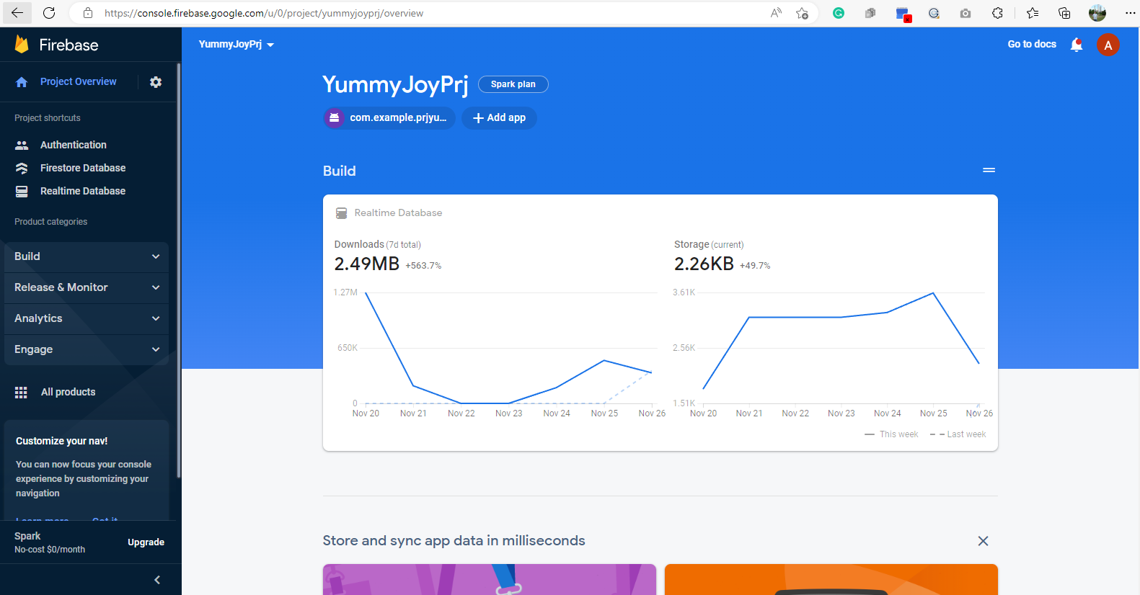

Data Configuration:

* We defined four base group documents (list collections) named user, item, faq and review:
* User: The users (client and provider) that have access to the application.
* Item: The products/meals created and published by the providers and reserved by the clients.
* Faq: The FAQ content to explain the aim and features of the application.
* Review: The reviews per grocery store or restaurant are given by the clients when they buy the meal or product.
* **Business layer and Class model implementation**

Project Name: PrjYummyJoy.

Technology: Java for Android Studio

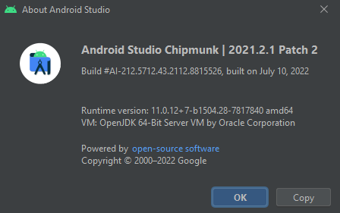

Backend Configuration:

* Model definition: We defined Client, Item, Review and Provider, and Enum Class ItemStatus (Status and UserType).
* Activities Definition: We defined the following activities:

1. ListItems (List the items, products, and meals, published)
2. LoginActivity(Access to the application by the user, Provider, or Client)
3. ClientProfileActivity(Menu options for the client, update profile, reserve meal/product).
4. PlaceProfleActivity(Menu options for the provider, update profile, publish meal/product).
5. PublishMealProductActivity(Publish meal/product available for the client).
6. RegistrationActivity(Register a new user as a Client or Provider).
7. ReserveMealProductActivity(Reserve a meal/product for the Client).

* Authentication: We implemented the authentication on the firebase users authentication where it provides a class called FirebaseAuth that allows to signin and signup users with methods that are part of this class. By defining and object It lets to create users with credential access with the registration of the user’s email and password, and also, the login to authenticate the registered user on the firebase database.

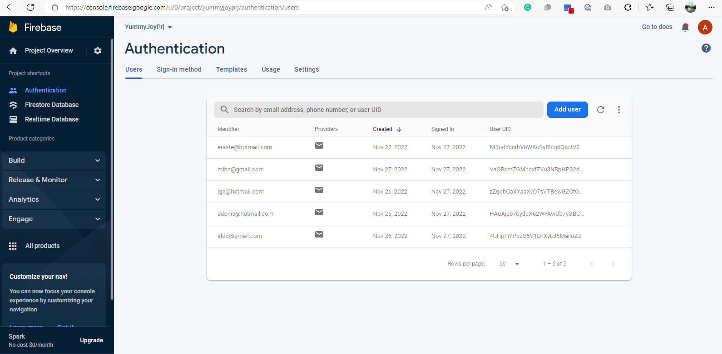

## Frontend

We defined the layouts based on the activities previously defined on the backend, and we added some styles to enhance the UI/UX experience and the management of the client and provider users.